Internship Project

Name: Aditya Singh
Domain: Machine Learning
Project Title: Credit Card Fraud Detection Using Logistic Regression
Submission date: 11/10/2025

Abstract:
This project aims to detect fraudulent credit card transactions using machine learning techniques. By analyzing transaction patterns and applying logistic regression, the model identifies anomalies that may indicate fraud. The dataset used is highly imbalanced, making it a real-world challenge for classification algorithms. The project demonstrates how data preprocessing, model training, and evaluation can be combined to build a reliable fraud detection system.

Objective:
- To build a binary classification model that distinguishes between fraudulent and legitimate credit card transactions.
- To evaluate the performance of logistic regression on an imbalanced dataset.
- To understand the impact of preprocessing and feature selection on model accuracy.
Methodology:
- Data Collection
- Dataset sourced from Kaggle: Credit Card Fraud Detection
- Data Preprocessing
- Load CSV data using Pandas
- Inspect and clean data
- Normalize features if needed
- Handle class imbalance (optional: SMOTE, undersampling)
- Train-Test Split
- Split data into training and testing sets (80/20)
- Model Building
- Use Logistic Regression from sklearn.linear_model
- Evaluation
- Accuracy Score
- Confusion Matrix
- Precision, Recall, F1 Score
Tools Used:
- Python –> Programming Language
- Pandas -> Data manipulation
- Numpy -> Numerical operations
- Scikit-learn -> ML models and evaluation metrics
- Google Colab -> Interactive coding environment
Step by step execution:
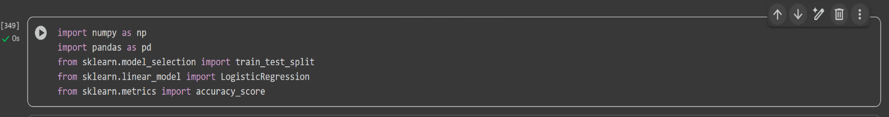
1. Import Libraries

2. Load Dataset

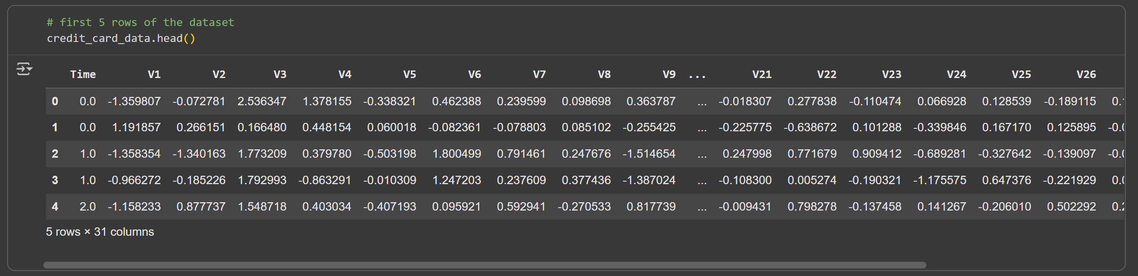
3. Printing first 5 rows

4. Getting the information of the dataset

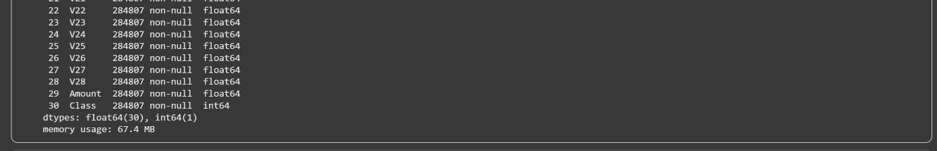
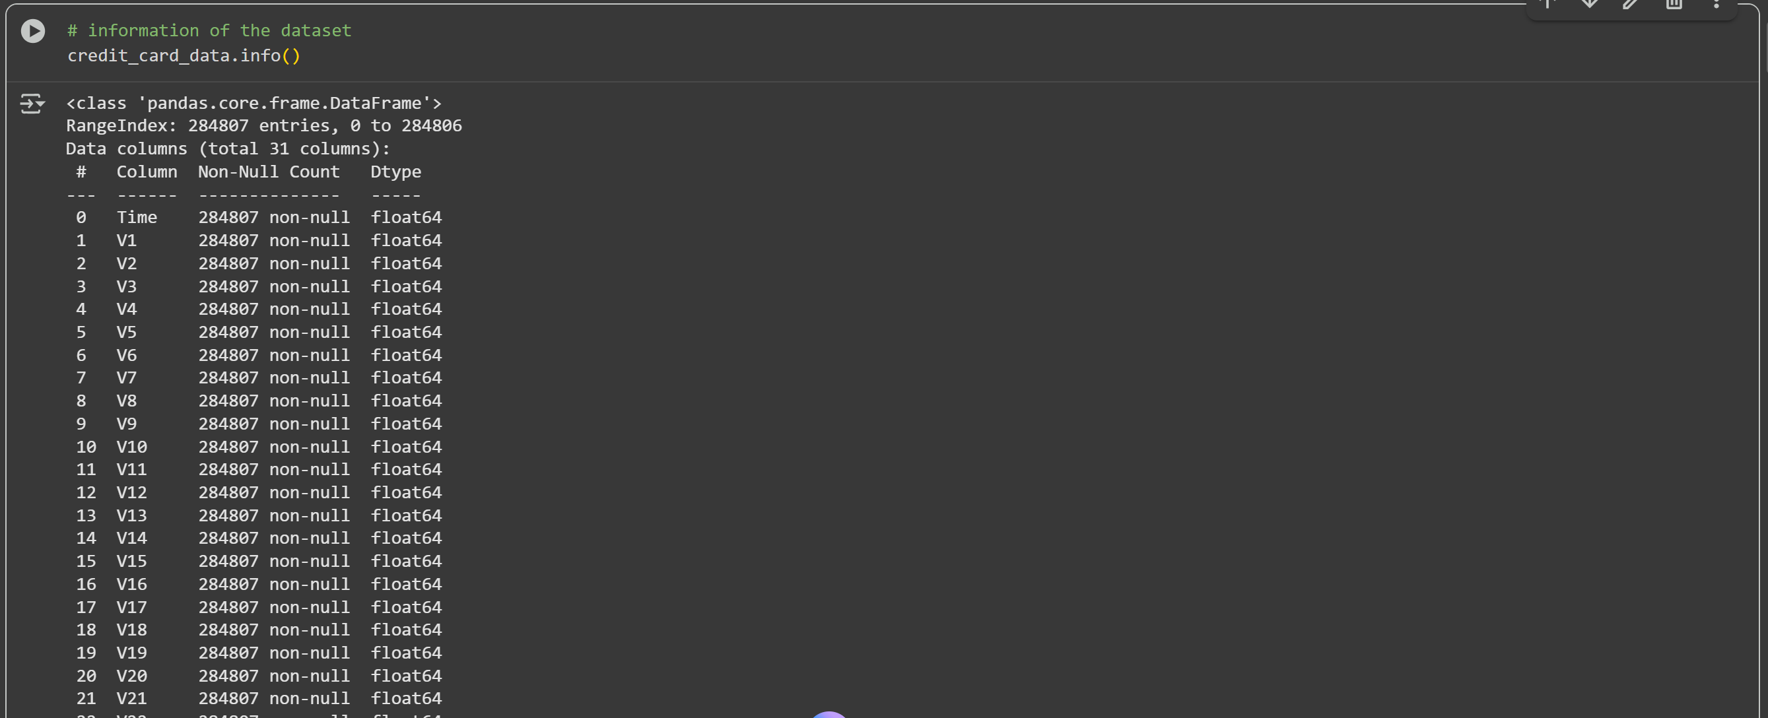

- Checking for the missing values
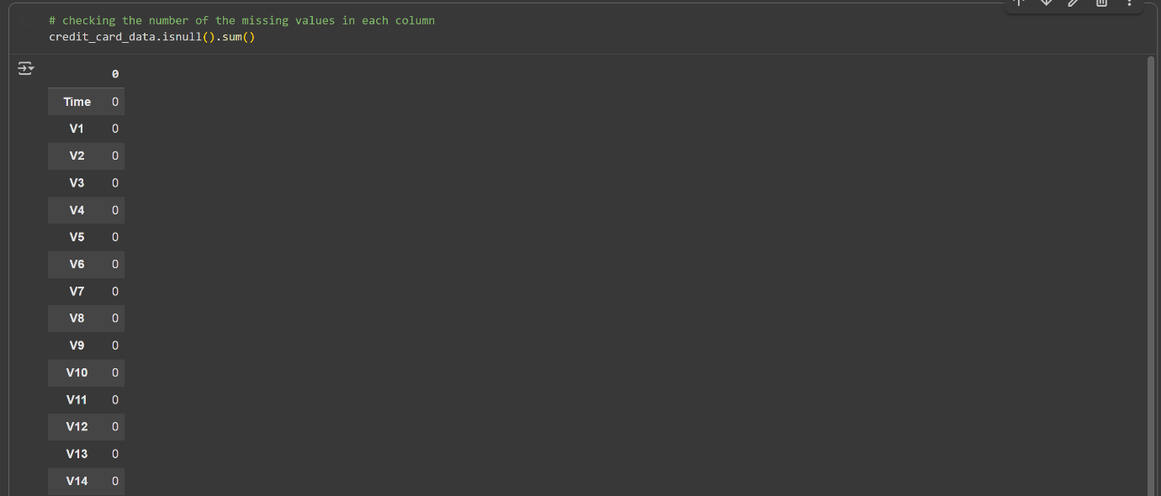



- Checking the distribution of the legit and fraud transaction
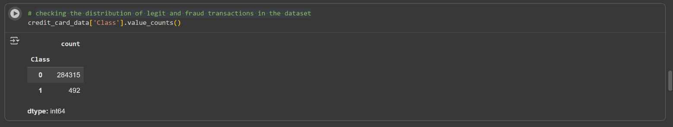

- Seperating the data for analysis
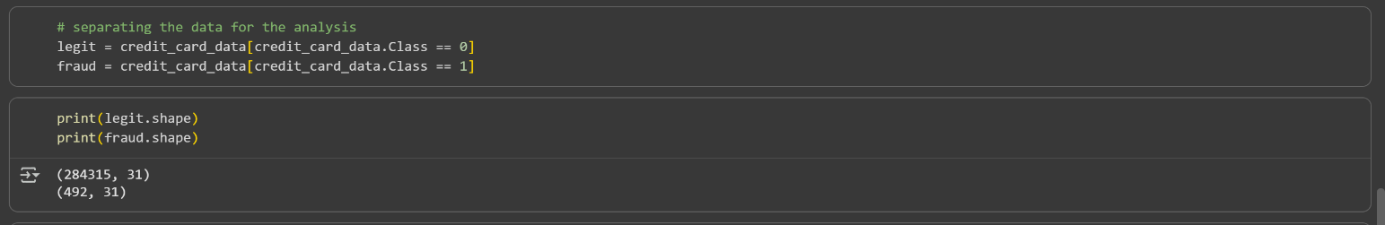

- Finding the statistical measures of the data
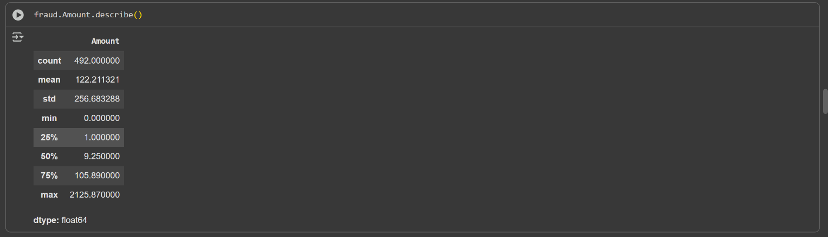
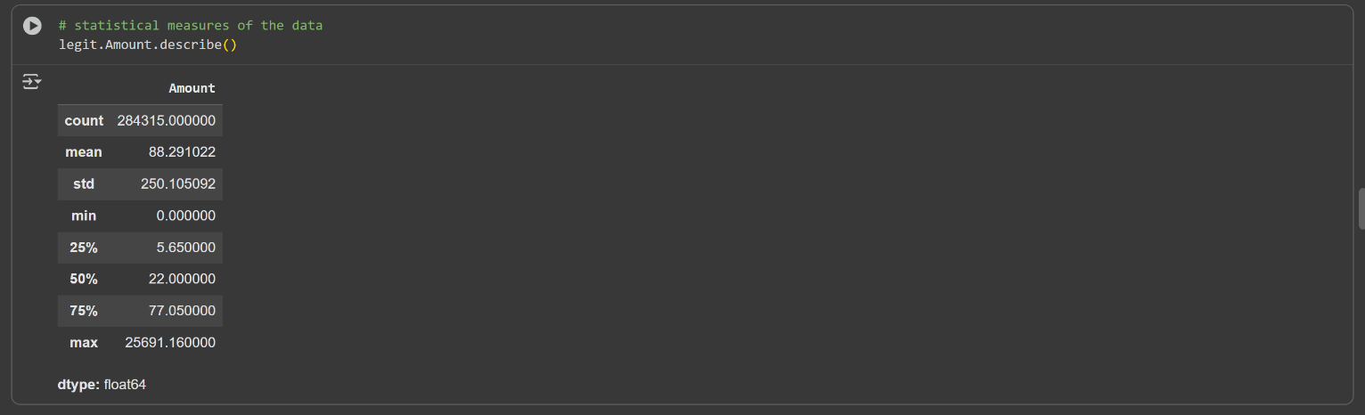

- Comparing both on the basis of mean
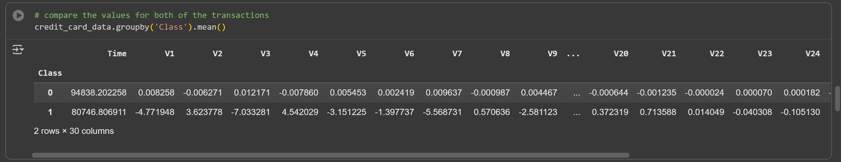

- Undersampling
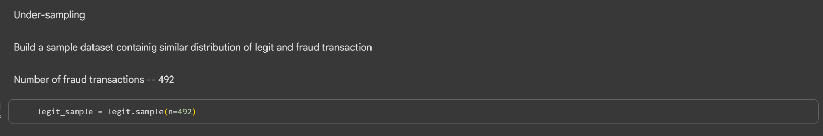

- Concatenating both datasets and comparing on the basis of mean
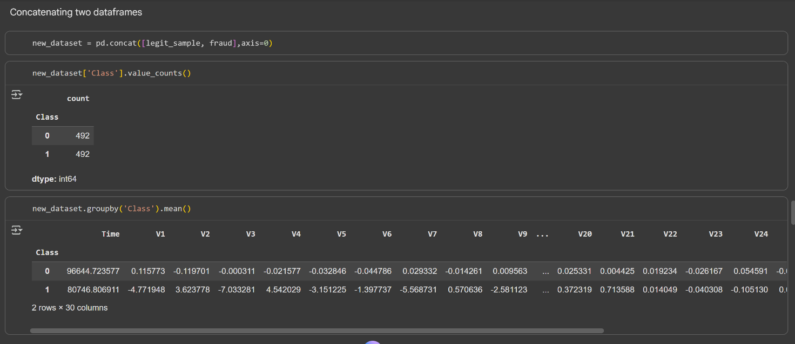

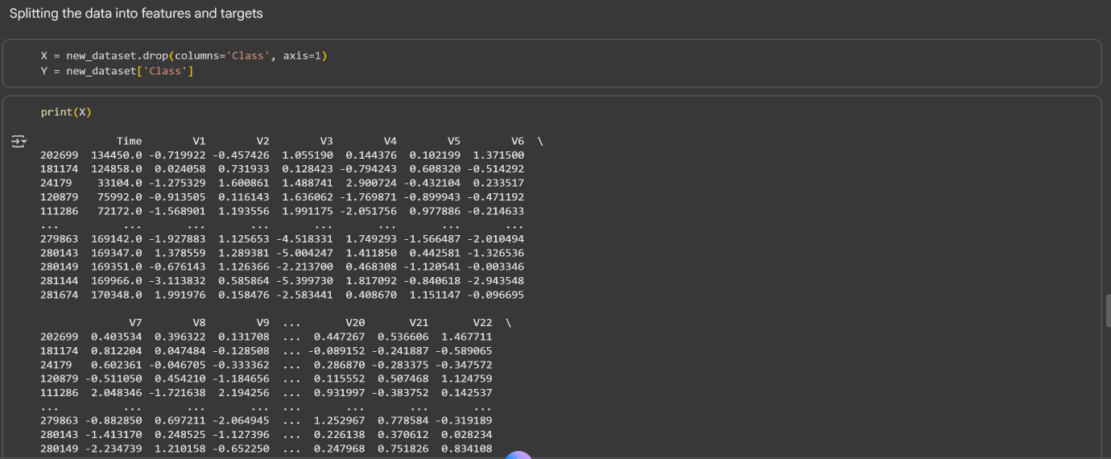
- Splitting dataset into features and target

\

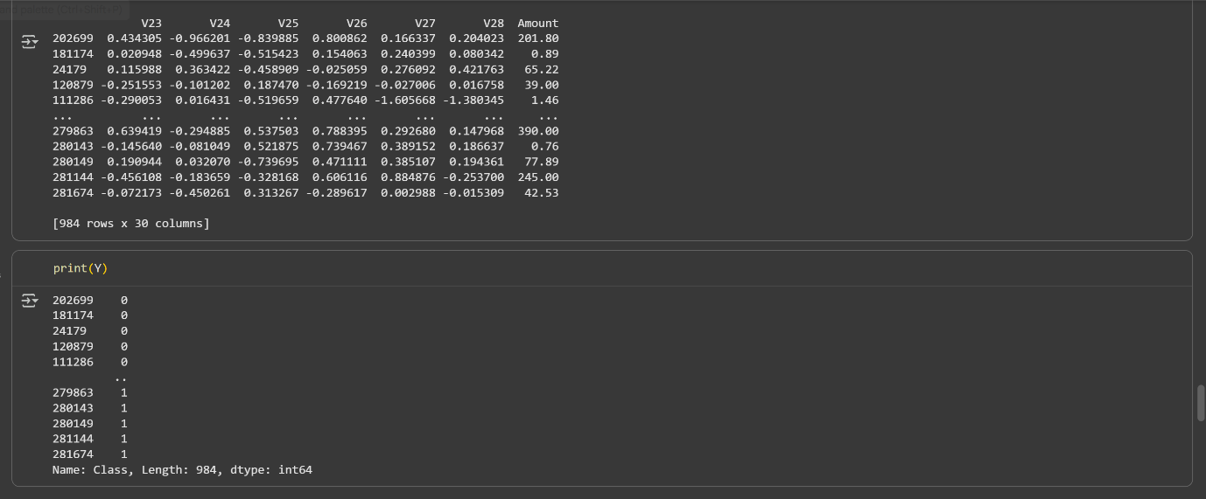

- Splitting into training and testing dataset
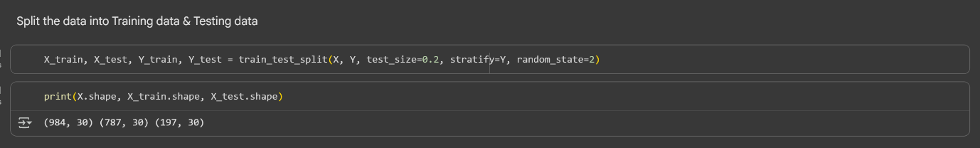

- Model training
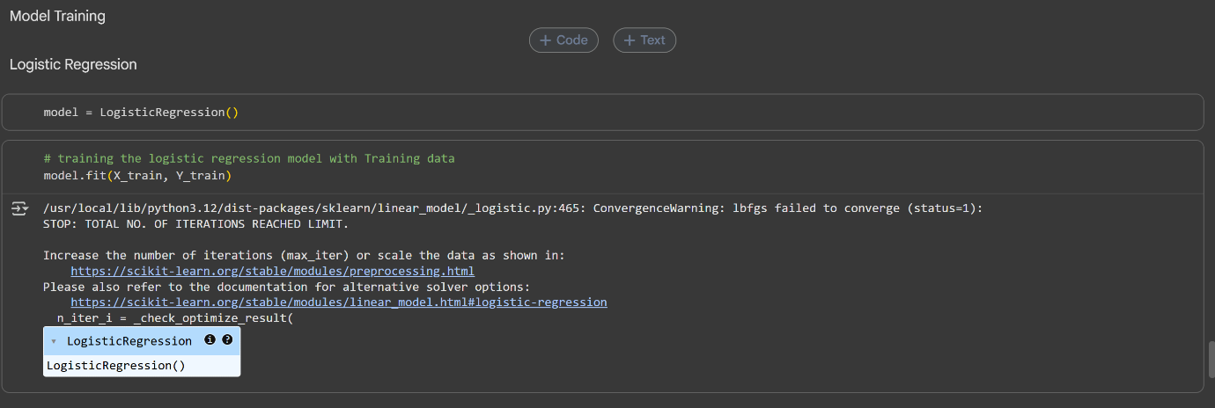

- Model evaluation
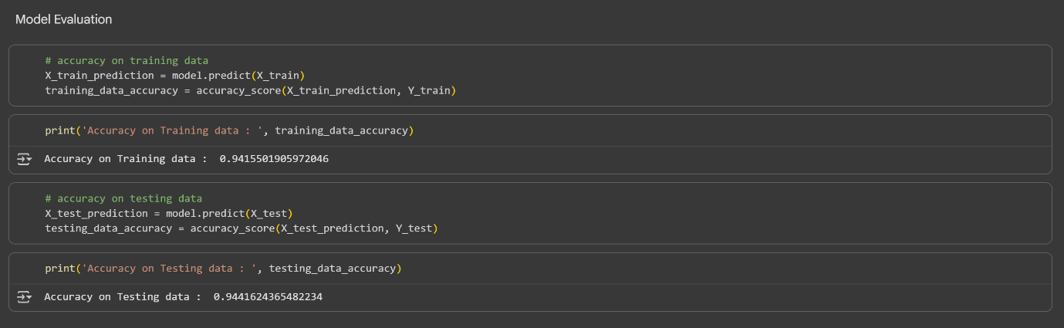

Final Output / Result:
- Accuracy: 0.944 (depending on preprocessing)
- Confusion Matrix: Shows true positives, false positives, etc.
- Model Insight: Logistic regression performs well but may struggle with class imbalance.
Conclusion:
This project successfully demonstrates how logistic regression can be applied to detect fraudulent transactions. Despite the dataset's imbalance, the model achieves high accuracy. Future improvements could include using ensemble methods like XGBoost or applying resampling techniques to improve recall on minority classes. The project highlights the importance of preprocessing and evaluation in building robust ML systems.

